Holy Family Parish
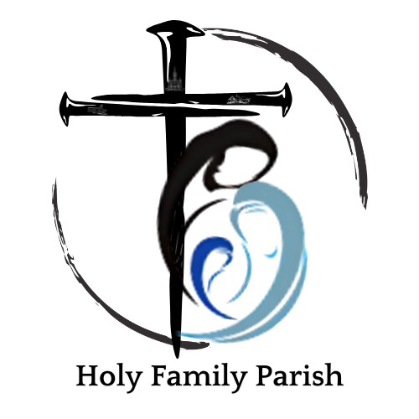

Employment Application
DRE / Youth Minister Position

Personal Information
Full Name:
Address:
City, State, ZIP:
Phone Number:
Email Address:

Education
High School:
College/University:
Degree(s) Earned:
Relevant Certifications or Training (Catechetical, Theology, Ministry):

Employment History
Most Recent Employer:
Position Held:
Dates of Employment:
Responsibilities:

Previous Employer:
Position Held:
Dates of Employment:
Responsibilities:

Parish and Ministry Experience
Please describe your involvement in parish life and any ministry experience (including sacramental preparation, youth ministry, OCIA, or catechesis):

Applicant Questions
1. What draws you to apply for the Director of Religious Education / Youth Minister position at Holy Family Parish?
2. Please describe your experience, formation, and background that prepare you for ministry in this role:

Diocese of Davenport Safe Environment & Background Check Requirements
All employees must comply with Diocese of Davenport Safe Environment policies. Please indicate the following:
Have you previously completed Safe Environment training? ☐ Yes ☐ No
If yes, where and when?
Have you previously undergone a background check for church ministry? ☐ Yes ☐ No
If yes, where and when?
Employment is contingent upon successful completion of diocesan background screening, Safe Environment training, and adherence to the Code of Conduct.

Conduct and Church Affiliation
Are you a practicing Catholic in good standing? ☐ Yes ☐ No
Parish of registration:
Please describe your understanding of and commitment to the mission of the Catholic Church:

References
Name, Relationship, Contact Information (include at least one pastoral/ministry reference):

Applicant Certification and Authorization
I certify that the information provided in this application is true and complete to the best of my knowledge. I understand that any misrepresentation or omission may result in disqualification or termination. I authorize Holy Family Parish and the Diocese of Davenport to conduct background checks and verify information as part of the hiring process.

Signature: ___________________________ Date: _______________

Submission Instructions
Please send your application along with resume to:
Holy Family Parish
PO Box C
Riverside, IA 52327

